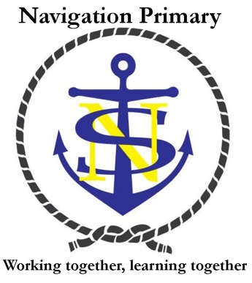
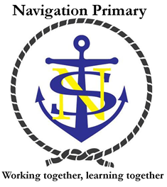
Curriculum at Navigation Primary School

Our curriculum seeks to give our children excellent core skills so that they can learn about the world around them and achieve their potential. At Navigation, our children come into school ready to learn and with a wide range of talents and interests so we believe that every subject is important and we invite our children to come along on a journey of discovery through the arts, science and humanities so that they have a broad base of knowledge to understand the world and shape their future.
To develop our increasingly diverse school population, we aim to provide a wide range of cultural influences through our topics, assemblies and lessons to challenge thinking and celebrate diversity. We also recognise that our children need to develop their independence and resilience so that they are ready for the challenges of the curriculum and their next phase of education. Children leave Navigation reflecting our core values: love of learning, respect for self and others, caring for others and our world and collaboration.

Intent (What do we what our children to know and understand from our curriculum?)
Subject | By the time children leave Navigation they will be learners who….
Personal development | have developed the Navigation values of caring, collaboration, and respect through everything we do including assemblies, visitors, school trips, Skills For Life lessons, MyHappyMind program and the example set by the adults in our school.  All children will have a true understanding of what it means to have a healthy and happy body and mind. We will aim to equip the children with tools to help them manage their emotions and create their own healthy habits.
English and mathematics | have developed excellence in English and mathematics skills to equip them to understand the world and have the crucial foundations to access all other areas of learning.
History | have developed a knowledge of an historical timeline and understanding of how history shapes the world today. Children will also develop in depth knowledge and understanding of particular events and people from the past.
Geography | have developed a knowledge of the world and its places. They will understand differences and similarities between people and places around the world and develop an appreciation for the diversity of the planet and the need to protect the natural environment.
Art | have developed knowledge of different artists and techniques, an understanding and appreciation of art and the skill to produce their own pieces of art.
Design and Technology | have developed an understanding of the plan, make, review process and knowledge of some design and designers. They will have also developed the skills to construct a range of designs with different materials and tools including use of ICT.
Computing | have developed a knowledge of coding and computing and understanding of how these technologies can help to children to develop computational thinking to access, use and create technology. They will know how to be safe online.
Music | have developed a deep love of music through critical engagement with a wide canon of music and the ability to compose their own music. They will have the opportunities to develop creativity and confidence through a range of instruments.
Physical Education | are inspired to be physically confident and fit and healthy enough to take on challenges including competitive sport. They will develop their coordination, tactics, fitness and skills in a range of sports and games.
Religious Education | can reflect on their own beliefs and values through studying different religions and developing knowledge and understanding of different belief systems. They will have an inclusive and tolerant approach to studying religion.
Science | have developed a deep understanding of the world through the scientific disciplines of biology, chemistry and physics and the scientific method. They will have an appreciation of the power of science to inform our world view and the benefits it has brought to humanity will also be acquired. Children will develop a curiosity about the world and the skills and vocabulary to enquire scientifically.
Modern Foreign Languages | have developed an appreciation for other cultures and languages and develop deeper knowledge and use of the French language.

Implementation (How will we deliver our curriculum?)
The curriculum is delivered in a variety of ways that best suit the needs and stages of our children’s development. Some subjects are taught discretely where this best enhances the learning of our classes. Some subjects are grouped together under topics where links can be made between different areas of the curriculum. Our whole school curriculum overview shows how each year group organises their topics. Opportunities to apply English and mathematics skills through other subjects are sought and exciting events, trips, visitors, parent events, special days all help to enrich and enhance our curriculum.
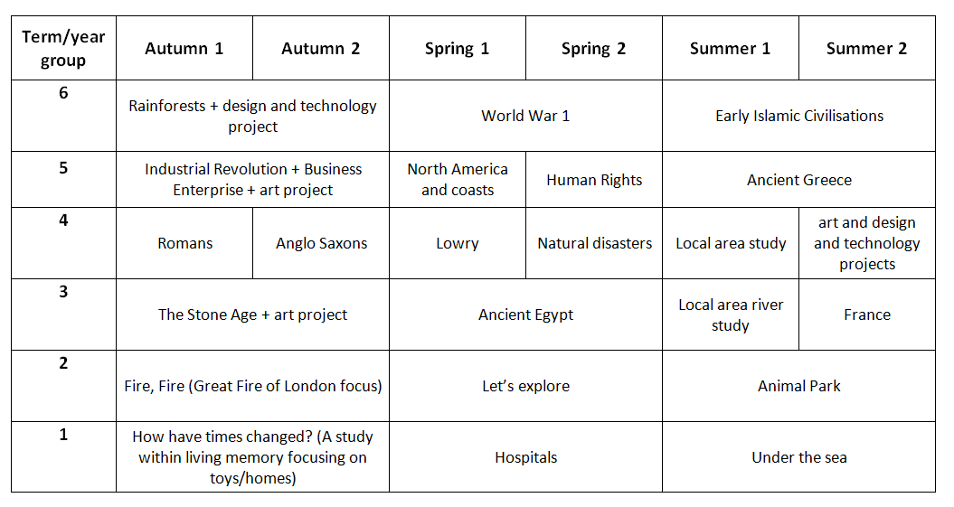

Impact (How do we know what the children can do and what they understand?)
Each subject is driven forward by a member of staff who monitors the attainment and progress of our children. We do this in a variety of ways including speaking to children, looking at their learning in their books, observing lessons and using data gathered from our school’s assessment system. This analysis can then be used to provide support and resources where needed to maintain high standards across all subjects.

