Week beginning 18th May

Here are some health and well-being activity ideas that you can do at home as a family. We would love to see the activities that you complete, please tweet us at @NavigationPS and include the hashtag for the activity that it is linked to.

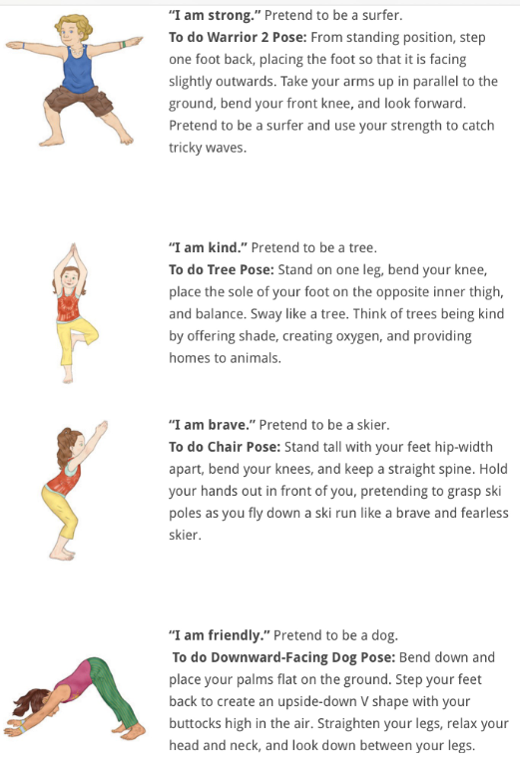  Check out @TraffordSSP on twitter for local Trafford school PE challenges | As the weather is supposed to be warmer this week why not try making your own ice lollies to keep you cool in the heat!  Sunshine lollies:  5 large carrots  juice of 3 large oranges  , zest of 1 satsuma, peeled then chopped (optional)  Finely grate the carrots and place in the middle of a clean tea towel. Gather up the towel, and squeeze the carrot juice into a jug, discarding the pulp. Add the orange juice and top up with a little cold water if needed to make up 360ml liquid. Stir in the orange zest and satsuma pieces, if using. Pour into lolly moulds and freeze overnight.  Watermelon ice lollies  1 small watermelon  3 kiwis  Halve 1 small watermelon and scoop the flesh out of one half into a bowl (you need about 375-400g). Pick out any black seeds. Purée the flesh using a hand blender or in a liquidiser. Fill ice lolly moulds three-quarters full with the purée, push the sticks in if you are using them, and freeze for at least 3 hrs, or overnight. Tip any remaining purée into an ice cube tray and freeze it.  Peel 3 kiwis and cut the green flesh away from the white core, discarding the core. Purée the flesh. Add a layer of about 4-5mm to the top of each lolly and refreeze for 1 hr. Add some green food colouring to the rest of the purée to darken it to the same colour as the watermelon rind. Pour a very thin layer onto the top of each lolly and freeze until you want to eat them.  Or try your own with any fruit you have at home!  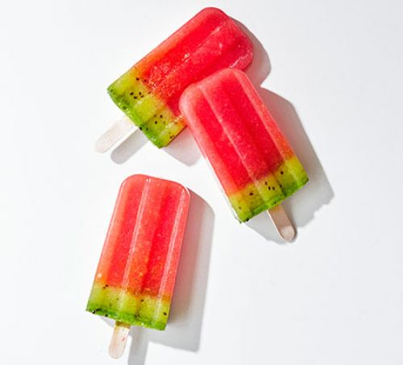 | As it is Mental Health Awareness week this week this is a great activity to calm down those worrying and busy thoughts!  https://youtu.be/nqQN4ugzj_g  (Cosmic Kids Zen Den_ | 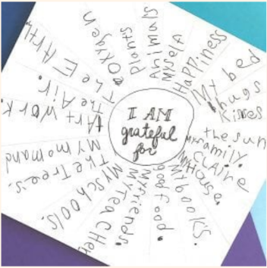  Create a gratitude wheel.  How do you notice when someone is kind to you? What kinds of actions do people take to show kindness? Discuss these actions, then describe how those actions feel in our bodies.  Write ‘I am grateful for’ in the middle and the people and things around it that you are grateful for. | Create a list of new places to visit near you once lockdown is eased.  It might be a park, beach or play area.  I would like to do the Rivington Pike walk.

