School Games Mark
School games values
The seven values of passion, belief, respect, honesty, determination, teamwork and eco were developed by young people to identify what the experience of school sport should be built around. These values have been successfully applied by schools to developing a range of behaviours, qualities and inter-personal skills with their students based on sporting experiences, scenarios and attitudes.
These Core values can be awarded at Intra and inter school competition and festivals as well as across the curriculum and could be used as a reward system in school.

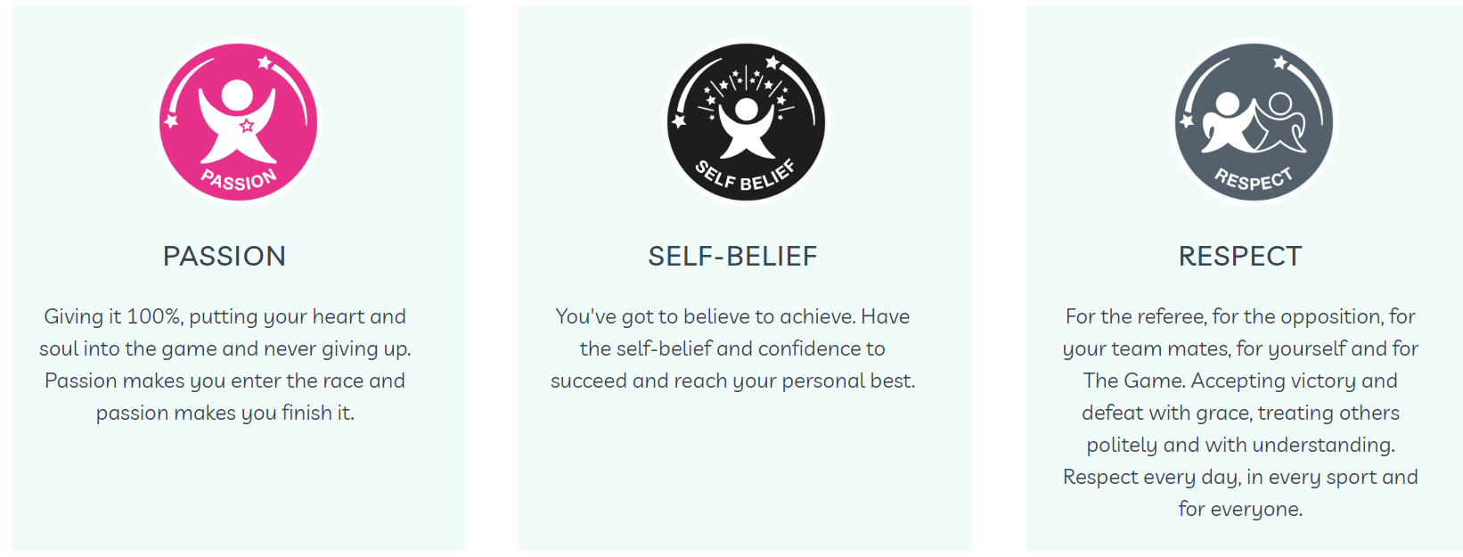

As part of Trafford School Sport Partnership (TSSP) membership, they offer access to a number of competitions across the school year. Our aim, as a school is to provide opportunities for all of our young children to represent the school in a sporting event.
TSSP offer a range of competitions throughout the year such as:
Excel events- competitive events for A and B teams
School games values events- giving children the opportunity to compete in school games activities but with a twist, E.G extra points scored for respect, determination
Festivals- to try new activities, have fun and enjoy themselves, develop friendships and meet new people

